Project – 1 Documentation

Scraping and Analysis of Stastistics of Sports Players from Real-Time Webpage

OVERVIEW :A project that gives you a better understanding of scraping data from websites and how to analyse them. Usage of various libraries as NumPy, Mat Plot, Pandas.

In the course of completing the project, you use the web scraping function, converting the extracted data into a pandas data Frame, and Storing the analysed data.

Problem Statement

Web scrape basketball statistics from Wikipedia of some of the greatest basketball players and export it as a CSV file format.

Software Requirements
1. Programming Language : Python
2. Environemnt: Jupyter Notebooks / Google Collab
3. Database: CSV(export type)
4. Operation System: Windows XP or above
5. Librarires Used: Beautiful Soup, requests, Pandas, NumPy, boto3 ,Matplotlib, display

- Open a New Notebook and import the required libraires
import bs4
import requests
import pandas as pd
import numpy as np
import boto3
import matplotlib.pyplot as plt
from IPython.display import display

Description:
Importing the modules to use the inbuilt functions and giving an alias to acess them easily

- Reading the webpage

def get_basketball_stats(link='https://en.wikipedia.org/wiki/Michael_Jordan'):
response = requests.get(link)
soup = bs4.BeautifulSoup(response.text, 'html.parser')

Description:
Requests.get is used to read the html page webpage
Bs4.beautifulsoup is used to phrase the collected html page

- Main Function Process
table = soup.find(class_='wikitable sortable')
headers = table.tr
titles = headers.find_all('abbr')
data = {title['title']: [] for title in titles}
for row in table.find_all('tr')[1:]:

for key, a in zip(data.keys(),row.find_all('td')[2:]):
data[key].append(''.join(c for c in a.text if (c.isdigit() or c == '.')))
Min = min([len(x) for x in data.values()])
for key in data.keys():
data[key] = list(map(lambda x: float(x), data[key][:Min]))
return data

Description:
Finding the wikitable sortable is identifying the table in the html page
Headers is the first row of the tablular column which are the headings
Titles is the words in the first row with which we identify the respective column
Creating a dictonary and passing the keys as the first row i.e the heading whose respective value is given by the data of that column
Zip is used to zip the keys and vlaues i.e headers and the respective column
We append only if the carácter is either a digit or and ‘.’ And no other character is appended
Finding the min is to identify only the required rows and not appending the remaining
Finally returning the data with all the keys and values
- Declaring links and names of the personals to scrap the data

links = ['https://en.wikipedia.org/wiki/Michael_Jordan'\
,'https://en.wikipedia.org/wiki/Kobe_Bryant'\
,'https://en.wikipedia.org/wiki/LeBron_James'\
,'https://en.wikipedia.org/wiki/Stephen_Curry',
'https://en.wikipedia.org/wiki/Pau_Gasol',
'https://en.wikipedia.org/wiki/Kevin_Durant',
'https://en.wikipedia.org/wiki/Chris_Paul',
'https://en.wikipedia.org/wiki/Kyrie_Irving',
'https://en.wikipedia.org/wiki/Tim_Duncan',
'https://en.wikipedia.org/wiki/Kawhi_Leonard']
names = ['Michael Jordan','Kobe Bryant','Lebron James','Stephen Curry','Pau Gasol','Kevin durant','chris paul','Kyrie Irving','Tim Duncan','khavi leonard']

michael_jordan_dict = get_basketball_stats(links[0])
kobe_bryant_dict = get_basketball_stats(links[1])
lebron_james_dict = get_basketball_stats(links[2])
stephen_curry_dict = get_basketball_stats(links[3])
Pau_Gasol_dict=get_basketball_stats(links[4])
kevin_durant_dict=get_basketball_stats(links[5])
chris_paul_dict=get_basketball_stats(links[6])
kyrie_irving_dict=get_basketball_stats(links[7])
tim_duncan_dict=get_basketball_stats(links[8])
khavi_leonard_dict=get_basketball_stats(links[9])

mj_table = pd.DataFrame(michael_jordan_dict)
kb_table = pd.DataFrame(kobe_bryant_dict)
lj_table = pd.DataFrame(lebron_james_dict)
sc_table = pd.DataFrame(stephen_curry_dict)
pg_table = pd.DataFrame(Pau_Gasol_dict)
kd_table=pd.DataFrame(kevin_durant_dict)
cp_table=pd.DataFrame(chris_paul_dict)
ki_table=pd.DataFrame(kyrie_irving_dict)
td_table=pd.DataFrame(tim_duncan_dict)
kl_table=pd.DataFrame(khavi_leonard_dict)
list_table =[mj_table, kb_table, lj_table, sc_table,pg_table,kd_table,cp_table,ki_table,td_table,kl_table]

i = 0
for name in names:
print(name)
display(list_table[i])
i += 1

Output:
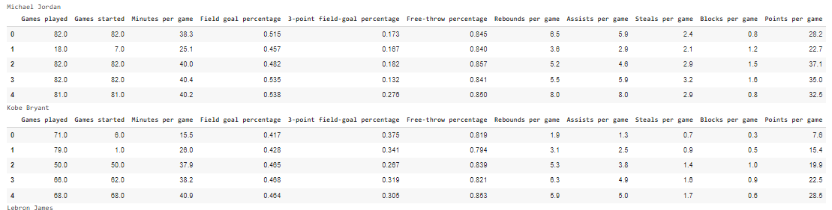

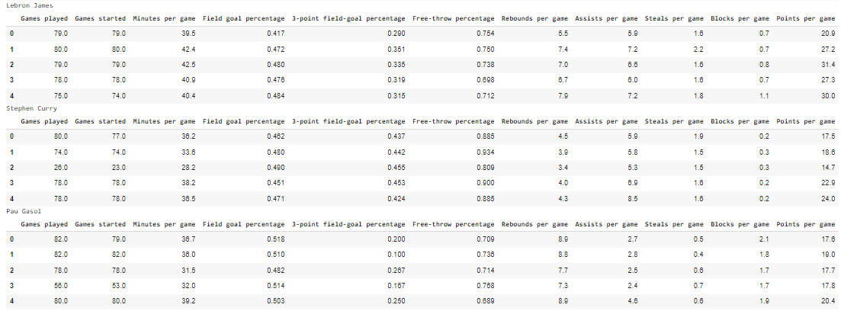

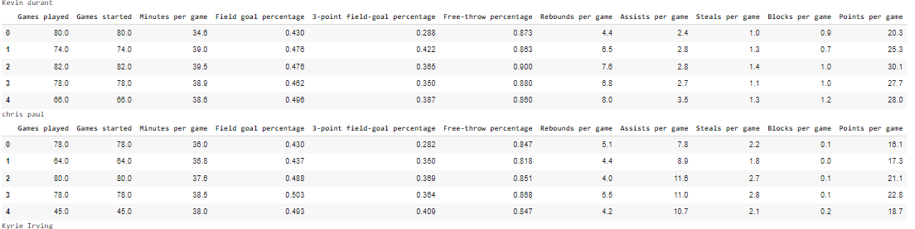
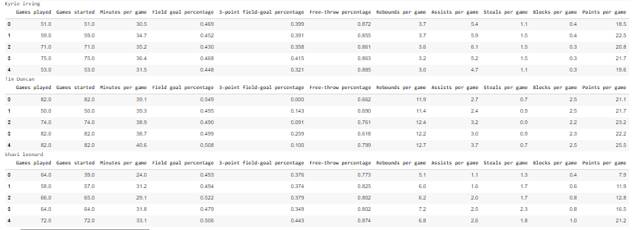

Description:
Tabular columns from the information available online using the inbuilt functions

6.Making a plot using matplotlib

j = 0
for name in names:
plt.plot(list_table[j][['Points per game']],label=name)
plt.legend()
plt.xlabel('years')
plt.ylabel('Points per game')

j += 1

Output:
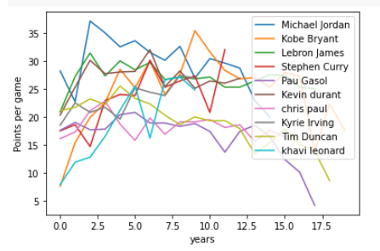
Description:
The performance of each player is plotted using the matplotlib from the available information with points on X-axis and years on Y-axis

Conclusion
This Project aims at collecting and scraping data from webpages online converting it into tabular columns and to plot the graph with available data using the matplotlib which makes it easy to analyze the players performance

